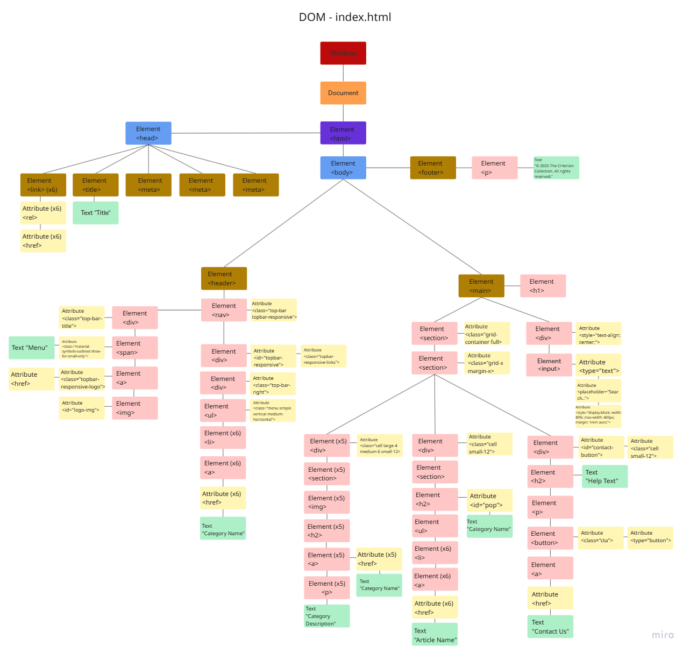

Link to online version of DOM: <https://miro.com/app/board/uXjVIveNGU8=/>